**Year 11 ATAR Chemistry**

**Investigation 1: Fuels**

**Part B**

**Name: ___________________­­­­­­­________ / 38**

1. An experiment was carried out to determine the heat of combustion (in kJ/mol)

for three different fuels (olive oil, methanol and biodiesel). The diagram below

shows the equipment used to conduct the experiment.

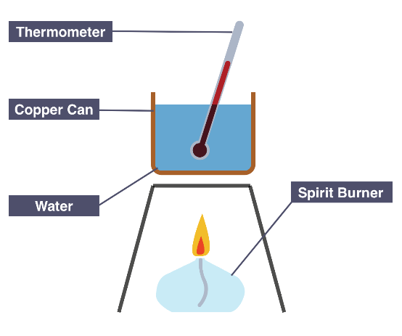

The spirit burner was weighed before and after heating. Approximately 100 g of water was placed in the copper can and the temperature of water before and after heating was recorded.

a) State three controlled variables for this experiment.

(Remember units and values where necessary.) (4 marks)

_____________________________________________________________________

_____________________________________________________________________

_____________________________________________________________________

_____________________________________________________________________

_____________________________________________________________________

_____________________________________________________________________

The following results were obtained.

|  |  |  |  |  |  |  |  |
| --- | --- | --- | --- | --- | --- | --- | --- |
| Fuel | Formula | Initial mass of fuel and burner (g) | Final mass of fuel and burner (g) | Mass of fuel burned  (g) | Initial temp. of water  (°C) | Final temp. of water  (°C) | Temp. change  (°C) |
| Olive oil | C18H34O2 | 204.60 | 204.51 |  | 22.9 | 43.0 |  |
| Methanol | CH3OH | 239.39 | 238.79 |  | 22.9 | 51.8 |  |
| Biodiesel | C19H34O2 | 190.20 | 190.09 |  | 22.9 | 41.5 |  |

b) Complete the results table above by filling in the missed columns. (2 marks)

c) Using the formula given below and the experimental results, calculate the heat energy in joules absorbed by the water from burning each of the fuels. (3 marks)

Energy(J) = mass of water (g) x specific heat x temperature

capacity of water difference

(specific heat capacity of water = 4.180 J/g°C)

d) Complete the table below by calculating the moles of each fuel burnt and hence the energy released (J/mol) by each fuel. (6 marks)

|  |  |  |  |  |
| --- | --- | --- | --- | --- |
| Fuel | Formula | Molar Mass of fuel  (g mol-1) | Moles of fuel  used  (mol) | Energy  released  (J/mol) |
| Olive oil | C18H34O2 | 282.452 |  |  |
| Methanol | CH3OH | 32.042 |  |  |
| Biodiesel | C19H34O2 | 294.462 |  |  |

e) Write balanced equations for the complete combustion of olive oil and methanol.

(4 marks)

_____________________________________________________________________

_____________________________________________________________________

_____________________________________________________________________

_____________________________________________________________________

_____________________________________________________________________

f) Describe two **major** sources of experimental error within this investigation. (2 marks)

_____________________________________________________________________

_____________________________________________________________________

_____________________________________________________________________

_____________________________________________________________________

_____________________________________________________________________

2. Diesel is a fuel that can be obtained from crude oil. It is used in most forms of

transport, from trucks, cars and tractors to aircraft and rail cars. Biodiesel is most

commonly produced from vegetable oil in a chemical reaction called transesterification.

It can be used in pure form, in many of the same vehicles as regular diesel, however it

is often used as a biodiesel-diesel mix.

a) Briefly describe two (2) advantages of using biofuels instead of fossil fuels as an

energy source. (2 marks)

_____________________________________________________________________

_____________________________________________________________________

_____________________________________________________________________

_____________________________________________________________________

b) State two (2) reasons it is not always possible for people to use biofuels. (2 marks)

_____________________________________________________________________

_____________________________________________________________________

_____________________________________________________________________

_____________________________________________________________________

The table below gives some information regarding diesel and biodiesel.

|  |  |  |  |
| --- | --- | --- | --- |
|  | Formula | Molecular mass  (g mol-1) | Energy output (kJ g-1) |
| Diesel | C18H34 |  | 44.98 |
| Biodiesel | C18H36O2 |  | 38.48 |

c) Complete the table by calculating the molecular mass (g mol-1) of each fuel. (2 marks)

d) Calculate the energy output of **diesel** in kilojoules per mole (kJ mol-1). (2 marks)

The equation for the combustion of **biodiesel** is shown below.

C18H36O2(l) + 26 O2(g) → 18 CO2(g) + 18 H2O(l) + 10946 kJ

If a sample of biodiesel was combusted and 9625 kg of CO2(g) was released into the atmosphere;

e) Calculate the mass of biodiesel that would have been consumed. Express your answer

to the appropriate number of significant figures. (5 marks)

f) Calculate the amount of energy released. (2 marks)

g) What mass of **diesel** would have been needed to release this same amount of energy? (2 marks)

**End of Validation**